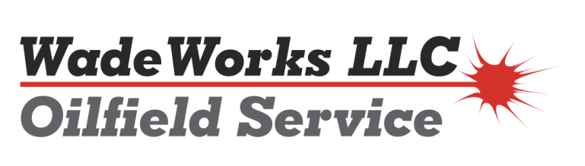
Roustabout Job Description
The roustabout is responsible for supporting the oil and gas construction operations. The position is diverse and may vary on a daily basis. The roustabout works with equipment he/she is qualified to operate such as a backhoe, dozer, maintainer, forklift, trencher, trucks, and trailers.
Duties include but are not limited to:
- Tank battery, treaters and equipment setting.
- Flow line installation.
- Heavy equipment operation and excavation.
- Install motors on equipment
- Responsible for tie-down of pumping units and installing counter weights for balancing.
- Install and repair pipelines.
- Hot shot services and TeNorm transport.
- General yard maintenance of ground and buildings.
- Trucking and snow removal.
- Must be able to safely lift 50 pounds.
- Other duties assigned by Management

Skills/knowledge
- Must be proficient with all tools including air and electrical
- Prefer 1 -2 Years oil & gas or construction industry experience
- Basic power & electric hand tool knowledge
- Ability to accurately complete daily paperwork
- Pass pre-employment and random drug tests
- Clean driving record with valid drivers license
- Willing to work days or nights as the work load dictates, guaranteed 40 + hours/week
- Ability to function on-call to respond to emergency call outs

